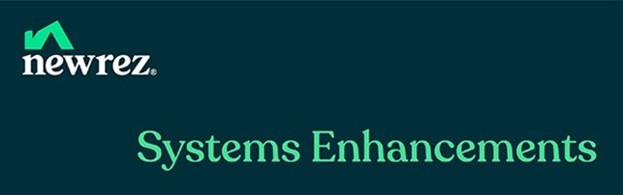

Newrez TitlePass
Wholesale & CL1

Starting January 22, 2026, Wholesale/CL1 loans will be eligible to receive a Title Waiver for applicable scenarios, provided the borrower and property address are successfully validated.

Discover how borrowers can save hundreds of dollars in closing costs on eligible refinance transactions!

Loan Eligibility | Exclusions
- Refinances only  - All income levels eligible  - LTV ≤ 80%  - States:  - Avenue Title Agency: AZ, NV, TX  - Avenue365: CA, CO, FL, GA, IL, IN, KY, MD, MI, MN, NJ, OH, PA, TN, VA  - CL1 loans may only be eligible when using Newrez AUS | - Units in a co-op  - Leasehold estates, including those on a community land trust  - Manufactured homes  - Non-Owner-Occupied Properties  - Properties subject to an unexpired redemption period  - Loans closing using a Power of Attorney

Key Highlights
Users will now see the “Title Waiver” section on the Clear Choice AUS Screen.
- Blueprint users should be running AUS prior to running Fees.
- AUS Example:
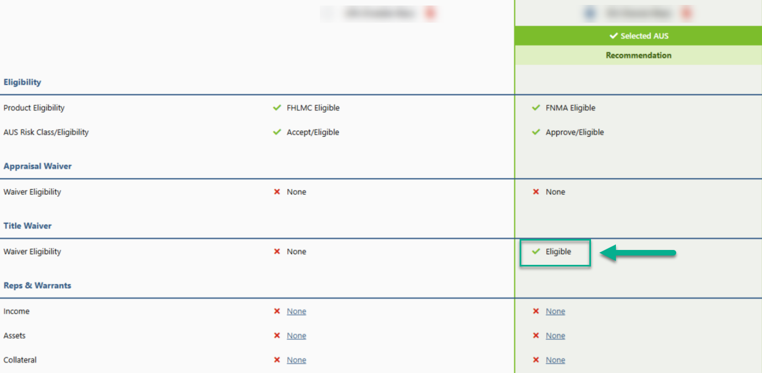
- If Fee Quote was run prior to AUS, once the title waiver is received, Blueprint users will be required to re-run Fee Quote.

Avenue 365/Avenue Title Agency is the only approved provider for Newrez to utilize the Title Waiver.

Ordering Title
- Title will automatically be ordered when the loan is submitted.
- An auto-generated note will be shown in the Notepad confirming the title order.
- The following documents will be returned from Avenue* and flow into EFM:
  - Pre-Closing Status Report (including Taxes)
  - Preliminary Closing Disclosure (CD)
  - Wiring Instructions

Scheduling Closing
- Newrez CRMs will be responsible for scheduling the Closing with Avenue.
  - Once the loan is Clear to Close, the CRM will coordinate with the Broker/Loan Officer to schedule a date convenient for the borrower.
  - Minimum of 48 hours required.

It is possible to lose/ gain a Title on a subsequent AUS run

*Avenue = Avenue365®/Avenue Title Agency based on property state.

Avenue 365® is a registered trademark of Avenue 365 Lender Services, LLC. By refinancing an existing loan, the total finance charges may be higher over the life of the loan. © 2026 Newrez LLC, 1100 Virginia Dr., Suite 125, Fort Washington, PA 19034. 1-888-673-5521. NMLS #3013. Doing business as Newrez Mortgage LLC in the state of Texas. Alaska Mortgage Lender License #AK3013. Arizona Mortgage Banker License #919777. Licensed by the Department of Financial Protection & Innovation under the California Residential Mortgage Lending Act. Loans made or arranged pursuant to a California Finance Lenders Law license. Massachusetts Lender #ML-3013. Licensed by the N.J. Department of Banking and Insurance. Licensed Mortgage Banker-NYS Banking Department. For licensing information, go to: www.nmlsconsumeraccess.org. For real estate and mortgage professionals only and not intended for distribution to consumers or other third parties.

